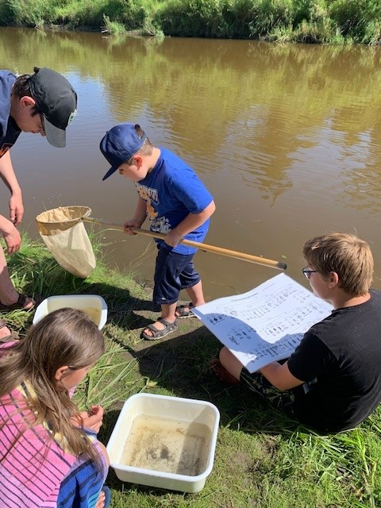
Journey to the Future
Sustainability Grant Application

Supported by:
Journey to the Future Grant Application
Club Name:
Project Name:
Date:
Names of members that completed Journey 2050, Farmers 2050, Watershed Explorer, Watershed Detective, or attended 2-H Summer Camp:

What did you learn from the above game?

What is your project idea?

What UN Sustainability Development Goals will this project address?

What is your action plan for this project?

Journey to the Future Grant Application
Club: Hoppity Hop Multiple 4-H Club
Project: Community Watershed Walk and Cleanup
Date: May 15, 2023

Harold, Flower, Thumper, and Bambi all completed the Watershed Explorer game from the Caring for our Watersheds website.
Through this game, we learned about watersheds and the important wildlife habitat that watersheds provide. We also thought about watersheds in our own community and what we can do to help wildlife and watersheds here in Carrotville, SK. Carrotville has a small creek that runs through it and our club would like to organize a community watershed walk and cleanup afternoon.
On the walk, we will look at the plants, animals, soil, rocks, and water while picking up any garbage. One of the problems in our community is the lack of garbage and recycling bins, leading to more garbage being thrown on the ground and ending up in our watersheds. We will work with the town to get more garbage and recycling bins along the walkway as well.
After the walk we will discuss what we saw and learned and end with a pizza supper.
This project will help to address the following UN Sustainable Development Goals
- Goal #6: Clean Drinking Water and Sanitation, by cleaning up the watershed.
- Goal #11: Sustainable Cities and Communities, by helping to build our community through a community event.
- Goal #14: Life Below Water, by protecting and learning about our water.
- Goal #15: Life on Land, by ensuring a clean and healthy watershed so we have water to drink and grow.
- Goal #17: Partnership for the Goals, by partnering with the town to ensure the success of our project through more garbage and recycling bins.
Our goal is to raise awareness about the importance of the watershed, learn about the plants and animals that live there, and help to keep our town clean. We hope to make this annual event.

Action Plan
Step 1: Plan Route along creek and book final destination for reflection and pizza
Step 2: Consult with town to organize garbage & recycling bins (March)
Step 3: Promotion to gain community support (April-May)
Step 4: Host Watershed Cleanup Day (May 15)
Step 5: Discuss what we learned and changes for next year’s event (May 15)
Step 6: Submit final grant report (June)

